Setting up a notice board

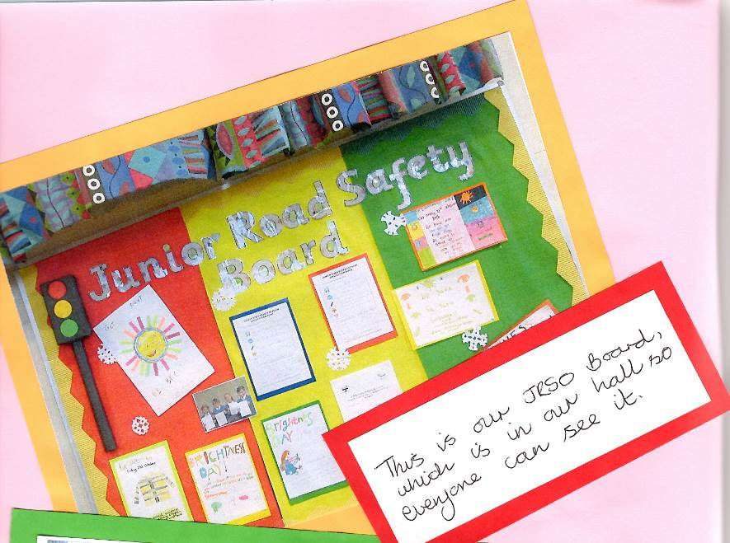
Ask your teacher to help you find a suitable notice board in your school, if possible in an area that can be seen by parents visiting the school as well as other pupils.

Your Area Road Safety Officer will be happy to help you get your board started, when they call. If you want to make a start yourself, ask your adult who oversees the scheme to help. Give it a nice clear heading.

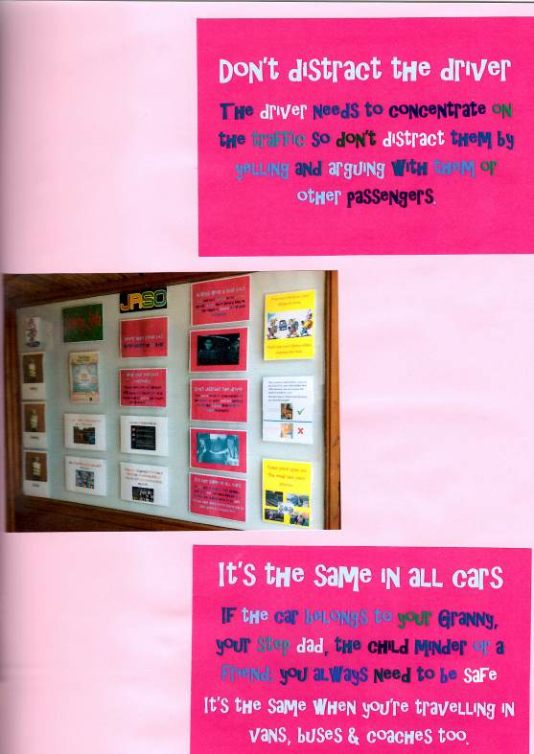
You can now add posters perhaps from competitions, and any of your own artwork with a road safety theme. It would be good to display the name of all the JRSOs and maybe make yourself a message section.
( see ideas below)

Free posters are available from:

https://www.think.gov.uk/education/

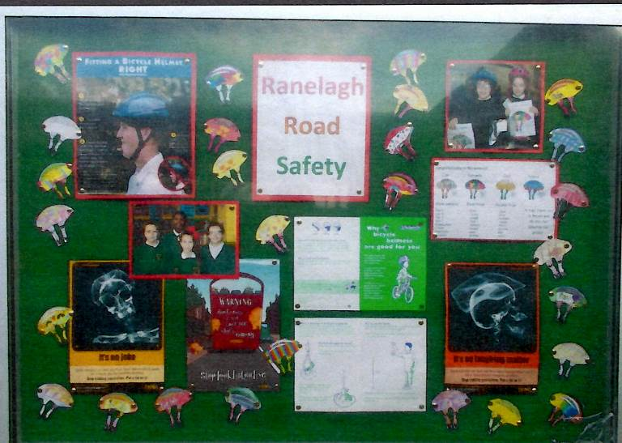
It's your board, so use it well and make it as attractive as you can. Change it from time to time (try at least each half term) to keep everyone interested in it.

Here are some examples from some schools across Suffolk:
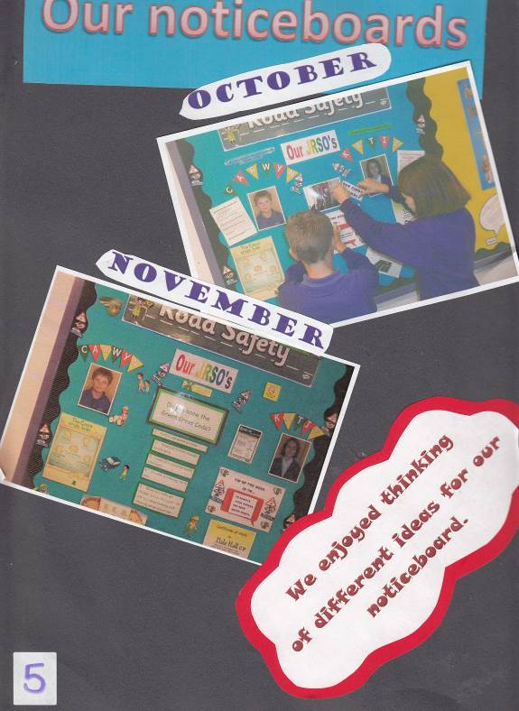

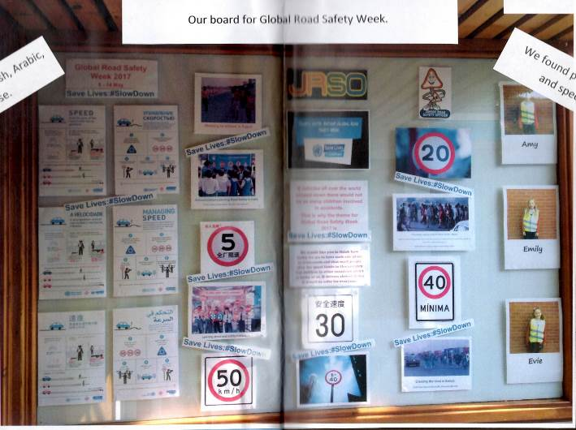

MESSAGES WITH A CYCLING THEME
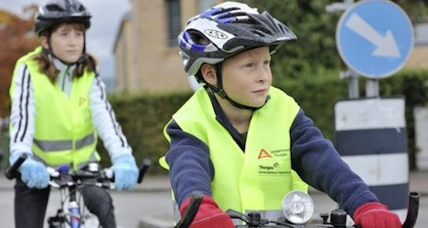
- Always remember to wear a cycle helmet when riding your bike.
- Make sure your cycle helmet fits well
- Park your cycle sensibly and securely
- Look after your bike and make sure it is safe to ride
- Always use both brakes to stop
- Plan your journey – find the safest route
- Respect other road users and pedestrians
- BEWARE! – it takes longer to brake on wet roads.

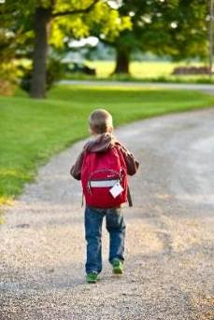
MESSAGES WITH A WALKING THEME
- Learn to use the Green Cross Code!
- Find a safer place to cross.
- STOP, LOOK, LISTEN, LIVE!
- Where there is a pavement, use it.
- Always walk across the road, NEVER RUN!
- If you are not sure, don’t cross – wait until you are!

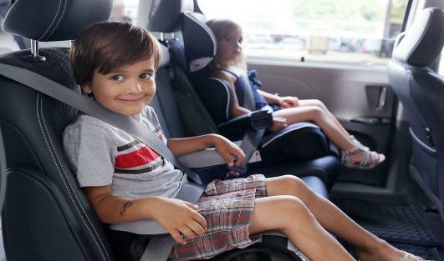

MESSAGES WITH A CAR TRAVEL THEME
- Be a safe passenger
- Always get out of a car on the pavement or verge side
- Always wear a seatbelt when riding in cars (and where available when on buses)

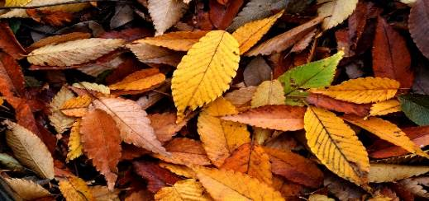
This Photo by Unknown Author is licensed under CC BY-SA

MESSAGE FOR THE AUTUMN TERM
- Clocks change, BE SAFE, BE SEEN!

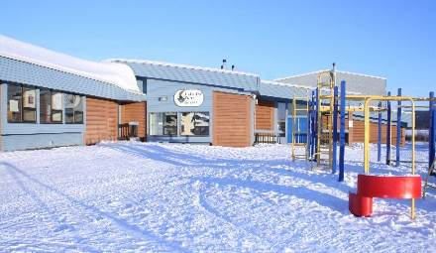

MESSAGES FOR THE WINTER TERM
- BEWARE ICY ROADS – it is harder for drivers and cyclist to stop.
- Getting a new bike for Christmas? Don’t forget that you will need lights for it and a helmet that fits too

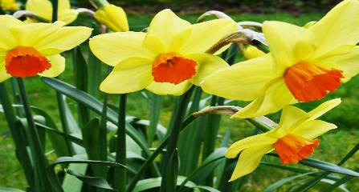
MESSAGES FOR THE SPRING TERM
- Clocks change, beware of darker mornings
- The sun is low and could dazzle drivers
- Learn to cycle safely – cyclist training coming soon!

