WORKING TOGETHER TO REDUCE SPEEDING (April 2026)

Suffolk County Council, Suffolk Constabulary and the Police & Crime Commissioner have worked together with local people for a decade to tackle concerns about speeding. We have developed an approach which offers both enforcement and education to suit the needs and concerns of local communities.

Individuals with concerns about speeding are encouraged to contact their Parish or Town Council to ask them to take action on their behalf. (In Ipswich, individuals should initially contact their local county councillors.)

There are 5 different ways we can approach the problem of speeding:
- Request Police Enforcement from the local policing team or ask for a visit from Suffolk SafeCam’s Community Enforcement Team.
- Form a Community Speed Watch (CSW) group to help educate drivers.
- Buy a Speed Indicator Device (SID) and have volunteers move it between sites.
- Request to be included on the County Council’s Temporary Vehicle Activated Sign (TVAS) programme or
- Request to be included on the County Council’s ANPR SID project schedule.

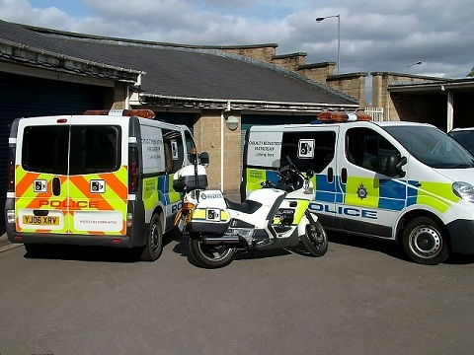 | 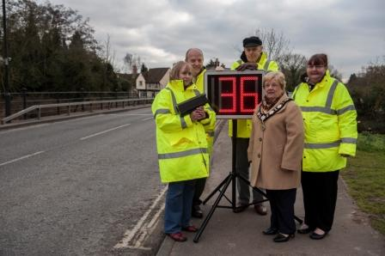
Police Enforcement | Community SpeedWatch volunteers
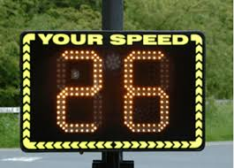 | 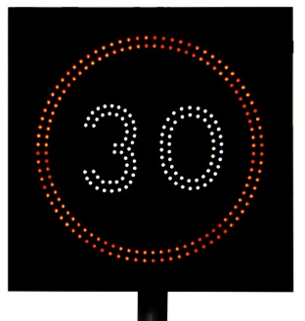
Parish/Town Council purchased SID | County Council deployed TVAS
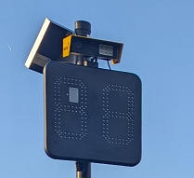
ANPR SID

- Police Enforcement
Concerns about speeding which require enforcement should be communicated to the Police. Details can be found on the Suffolk Police website www.suffolk.police.uk . Proactive speed enforcement only takes place in Suffolk at locations where there is an on-going risk of collisions, where a number of fatal or serious injury road traffic collisions have occurred or where there have been substantiated complaints.
Suffolk has operational camera sites at:
- A140 Coddenham
- A12 Benhall
- A14 Orwell Bridge (Average Speed Camera)
- A12 between East Bergholt and Stratford St Mary (Average Speed Camera)
- A134 north of BSE (Average Speed Camera)
The SafeCam Team operates a number of mobile enforcement vehicles, which are deployed across the county of Suffolk. Requests for their deployment are discussed at a monthly tasking group. Locations are displayed weekly on the Suffolk Constabulary website and information can also be found on Twitter at @NSSpeedCameras
Requests for Safecam support should be sent by email: SafetyCameraTeam@suffolk.police.uk
- Community Speed Watch (CWS)
This initiative allows members of the community to address the issue of speeding by becoming actively involved in road safety, monitoring speeds at safe locations with speed detection equipment. The aim is not to catch as many speeding drivers as possible but to reduce speed in areas of concern. It informs drivers that excessive speed is socially unacceptable and helps to re-educate drivers about the dangers of speeding while addressing concerns from residents about cars speeding through their neighbourhoods.
The intention is that Parish and Town Councils will purchase their own speed gun which is often used in conjunction with a Speed Indicator Device (SID), enhancing the CSW activities.
How CSW works:
- Trained volunteers verify and record the registration numbers of offending vehicles.
- These details are forwarded to Suffolk Police who will send offenders a letter.
- A maximum of two letters will be sent to offenders.
- Persistent offenders may be targeted for police enforcement.
- Follow-up work on education and enforcement by Suffolk Police and our partners will also take place when appropriate.
For further information about the scheme, please visit the Suffolk Police website.
For existing CSW co-ordinators wishing to learn more about the SID loan scheme, please email:suffolkroadsafe@suffolk.gov.uk
- Speed Indicator Device (SID)
Parish and Town Councils (Local Council) can purchase their own Speed Indicator Device (SID) with volunteers moving it from one predetermined site to another within 30mph restricted roads. Residents and Councillors know their community better than anyone and by completing a Site Suitability Checklist identify sites for themselves. They then submit completed Checklists to Suffolk County Council to have the individual sites “signed off”. Once a short Agreement has been completed the local council is then authorised to operate their SID at the approved sites. The Checklist and Agreement are included within this document.
As Ipswich does not have a Local Council system it is more difficult to operate a SID. However, Ipswich County Councillors may apply for a SID post, following the same site acceptance process that is in place for town/parish councils.
Doing this, the County Councillor accepts responsibility for:
- Correctly filling in the site suitability checklist and engaging with local residents using the templates in this document (Page 10). The installation of an approved post will be undertaken by Suffolk Highways).
- Researching and purchasing a SID device (as is the case for a town/parish).
- Installing the SID device and ensuring the protocols set out in the ‘Safety Management’ section of this document (Page 5) are adhered to (as is the case for a town/parish)
- Covering any costs associated with the SID. This includes the purchase and any servicing/maintenance costs as well as replacement costs (vandalism, manufacturing or age related). The county councillor is responsible for arranging and paying for any of these (as is the case for a town/parish). Suffolk Highways will only be responsible for the post to which the SID can be mounted (as is the case for a town/parish).
- Informing Suffolk County Council when they have purchased a SID, including the location(s) where the SID will be in operation.
If it is still not possible for a county Councillor to use SIDs in their area, they can apply for a post to be installed at a suitable location and for it to be included in our regular TVAS rotation (see section 4 below).

Step - by Step Process:
- The Local Council decides that a SID may address concerns about speeding.
- Discussion about sites, availability of volunteers required to move the SID, possible partnerships with adjacent Councils and the cost of purchasing a SID.
- Download and complete Site Suitability Checklists for each individual site; complete and submit to Suffolk Highways via sid-tvas@suffolk.gov.uk with written evidence that local residents do not object to location of SID/TVAS. (See draft letter for residents in FAQs.)
- SCC staff reviews site(s), confirms if suitable and returns copy of counter-signed Checklist.
- Local Council decides to proceed and negotiates with manufacturer to purchase a SID (prices vary considerably as a number of additional features are available such as red/green display, smiley/sad face, SLOW DOWN/ THANK YOU, speed data collection).
- If the SID is to be powered by a solar panel rather than a battery this may impact on the post size and foundations (see FAQ). This information should be provided with application.
- The local Council also needs to purchase a mounting bracket with the SID; it is preferred that the bracket is moved with the SID although some chose to purchase a bracket for each site and leave in-situ. Bracket should be the same colour as the SID.
- Local Council download Agreement, complete and return to sid-tvas@suffolk.gov.uk as confirmation that they have purchased a SID and wish to join the scheme.
- Local Council provides training for volunteers to move SID and commences operation.
Critical issues to be considered by the Parish or Town Council identifying suitable sites:
- Ideally 100m clear sight line, wholly within 30 mph limit but not at junctions or on roads with high densities of driveways, where the SID may obscure or distract from other traffic movements.
- A minimum distance of 80m will be accepted but it has to be sufficiently within the speed limit to not catch those who are still braking as they enter the restriction.
- No significant distractions, such as bends, crossings, junctions, high density of roadside development etc.
- No existing features that would or would have potential to interfere with the sight line such as road signs or vegetation, unless, in the case of the latter, they can keep it cut back.
- The proposed location must provide 0.5m lateral clearance of the device to avoid it being struck by an HGV mirror.
- The ground should be reasonably wide and flat to work at safely.
- The SID should ideally be sited on the near side of the road.
- There must be suitable off-road parking area available within the vicinity for the Parish Representative to erect / remove device (and for SCC’s contractor to replace/install pole if required, protected by parked vehicle).
- Using an existing sign pole is preferred; Suffolk CC will determine if one is tall enough to give correct mounting height and replace if necessary.
- If a new pole, a suitable sign should already be present for when the SID is not in use to avoid leaving a bare pole; the Kill Your Speed “campaign” poster should be provided when confirming the go-ahead.
- Suffolk County Council will try to provide the first two posts for a SID or TVAS scheme free of charge within a parish. Additional posts or alterations to posts proposed at the time or at a later date will incur a cost as specified below:
Standard 76mm OD (outside diameter) Posts for SID or TVAS schemes: £315
89mm OD (outside diameter) Posts for Solar SIDs: £630
- SIDs should not be attached to street lighting columns, telephone or electricity poles.
- On a verge, the lower edge of the SID should be between 1.3 – 1.5m above the adjacent carriageway; if over pavements 2.1m is acceptable but 2.3m preferable. However, if routes are used by cyclists, it may be necessary to provide 2.5m clearance.
- Support must be obtained from residents adjacent to the site.
Site Suitability Checklist: A separate form must be completed for every single site and submitted. Suffolk CC will review each site, confirm if suitable then return to the originator a counter-signed copy of Checklist. If residents object to a particular chosen site that is a matter wholly for the Local Council to resolve and the County Council will not get involved in any dispute if they proceed with a particular site against the wishes of a resident.
There will always be the odd occasion that SCC determines that a site is not suitable, but we hope this will be a rarity and the reason for rejection will be made clear.
Agreement: It is an essential part of the process that the Local Council enter into a formal Agreement with the County Council to cover the delegation of management responsibility to another tier of local government. Local Councils must also purchase their SIDs directly from the manufacturer, but some guidance is available; the local County Councillor may be prepared to make a contribution to the SID purchase. Once the Local Council has committed to proceed, they then download a copy of the Agreement, complete and return to Suffolk Highways as confirmation that they are purchasing a SID. At this point SCC will then, if necessary, replace existing sign poles to give correct operational height or install new poles as required.
The Agreement confirms that the Local Council will provide training and high-visibility clothing for volunteers before commencing operation of their SID.

.

SAFETY MANAGEMENT
Local Council deciding to manage a SID will be responsible for ensuring that safe systems of work are adopted and followed by volunteers, taking into account the risks to both volunteers and road users. SCC can offer advice on setting up a SID.

SCC recommends:

- A minimum of two people to be present when a SID is being placed or removed, or batteries changed, with one person whose role is to watch over the operation including observing oncoming traffic.
- A mobile phone to be available with contact numbers to call for assistance if needed.
- Where it is reasonable to do so, a SID shall be mounted at a height which does not require climbing on to any step or platform. Where there is no other suitable location, we may recommend a higher mounting height up to 2.3m where the proposed location is adjacent to or above a footway. In this instance the Parish or Town Council will be required to understand the risks associated with installing and removing a SID at this height before confirming that they would like to proceed.
- Any vehicle used for transport to the location to be parked in a safe place. If it is possible to park safely on the road, this can help move passing traffic further away. This is especially important if it is necessary to work from a step or platform.
- High visibility clothing to be worn (minimum of long-sleeved high visibility jacket). If working on uneven ground, boots with good ankle support to be worn.
- Where it is necessary to work off the ground, a platform or set of steps should be selected most suited to the location(s). The HSE toolkit for working at height can be found at
https://www.hse.gov.uk/pubns/indg401.pdf . Among the factors to consider are:
- The platform or steps must be free standing and self-supporting, not leant against a post or similar.
- Use individually adjustable feet or levelling mats to ensure stability where ground is uneven.
- People using the steps or platform must be sufficiently fit and able to do so safely.

- Temporary Vehicle Activated Signs (TVAS)
If a Local Council is unable or unwilling to run a CSW group or manage their own SID they can request inclusion in the County Council’s TVAS programme. We have a number of movable VAS which, when triggered, display the speed limit red roundel sign with “SLOW DOWN”. These are deployed by our Contractor at each agreed site for 2 weeks, 2 or 3 times a year.
Site Suitability Checklist: In exactly the same way as for the Local Council owned SIDs, the community identify suitable sites and the Local Council complete the Site Suitability Checklists and submit them to Suffolk Highways for review. The same criteria apply except TVAS can also be used within 40 mph restrictions, whereas a SID cannot, for reasons of volunteer safety.
If a site is suitable, inclusion in the deployment programme is at the discretion of the SCC’s Road Safety Manager. Priority will be given to sites when there is a record of traffic casualties. To avoid confusion TVAS will not be deployed in close proximity to community operated SID sites.

Requests for a TVAS site in Ipswich should be submitted directly to Ipswich County Councillors. https://www.suffolk.gov.uk/council-and-democracy/councillors-and-elected-representatives/find-your-councillor An assessment about the suitability of a site will be carried by SCC officers using the site suitability checklist and approval for the siting of a TVAS will be sought from the residents closest to the location.
Details of the dates and location where the TVAS are deployed is updated regularly and published on www.suffolkroadsafe.com

- ANPR SID – details of the project can be found at: www.suffolkroadsafe.com

FREQUENTLY ASKED QUESTIONS – SID, TVAS & ANPR SID

QUESTION | ANSWER
Requests/General
If drivers are seen to be exceeding the speed limit, will they be prosecuted? | The SIDs, TVAS and ANPR SIDs are used for educational purposes, not enforcement. Drivers will not be prosecuted.
We can afford to purchase a SID but cannot find a volunteer to install it; will SCC do it on our behalf? | Unfortunately, SCC is not in a position to do this. Some organisations may choose to pay individuals to carry out this work. If the site meets the suitability criteria, then a request could be submitted for inclusion on the TVAS deployment rota.
We have concerns about speeding in Ipswich, can we have a SID? | Because there isn’t a Local Council system in Ipswich, all requests for a SID/TVAS all will need to be considered by the local county councillor (with a SCC officer) and if it is deemed appropriate (a suitable location funding and resident’s approval) then a SID/TVAS post will be installed.  All operations/maintenance of SIDs in Ipswich will be the responsibility of the local county councillor (see Section 3)
As a resident, I am concerned about speeding, can I request a SID? | SCC will only consider requests from an organisation (or elected representative). Please express your concern to your local Parish or Town Councillors and propose this option.
As a resident, I object to the chosen site. Who has the final say? | This is a matter for the Local Council to resolve and SCC does not wish to be involved in any dispute over sites which are opposed by a resident.  To avoid disputes with residents, Local Councils are required to provide evidence that residents have been consulted when submitting site proformas. See below a draft resident letter.  If a resident has objects to the location, then there is no requirement for SCC to see the letter. The location will not be considered. If resident has approved the location, then the letter should be submitted with the Site Suitability checklist.
Can a SID be used in a 20mph or 40mph limit? | SIDs can only be used by volunteers within 30mph or 20mph restricted areas; the increased risk of working with potentially higher traffic speeds within a 40mph area is not acceptable.  N.B. The SCC owned TVAS can be deployed in 40 mph restricted areas by our Contractor with additional safety measures.
Can a SID be used on a private road | The use of a SID on a private road is a matter for the Parish/Town Council to discuss with the owner(s) of the road.
Assessments
What happens if SCC rejects the site assessed as suitable by the Parish/Town Council? | SCC will state its reason for rejection against the stated criteria, but it should be obvious when working through the checklists if a site is suitable.
Is there an appeal process? | It is hoped that the Local Council can identify an alternative site however it will always be possible that there is no suitable site from which a SID or TVAS can be operated.
Legal Agreement
Why is it necessary for a Council to sign a formal Agreement? | SCC is responsible for the highway. In this instance SCC is prepared to delegate powers to organisations however it is necessary for SIDs to be erected correctly and volunteers must operate safely. Without that written reassurance, SCC is unable to allow an organisation to proceed. Organisations will be responsible for arranging insurance to cover the use of the SID and for developing and operating safe systems of work.
Site specific
What happens if there is not a suitable post for the SID to be attached to? | Using an existing signpost is preferred. SCC will determine if an existing post is tall enough and replace if necessary. Alternatively, SCC will install new posts if required.
How many sites can a Local Council request for assessment? | There is no limit to the number of site requests that a Local Council can submit however SCC is anxious not to have numerous empty posts and installations are limited to 6 posts.
What happens if a post gets damaged? | The damage should be reported directly to sid-tvas@suffolk.gov.uk The post will be replaced free of charge within 14 weeks, in recognition of the work being done by the local community.
The site is within a conservation area, will that be an issue? | Generally, SCC standard traffic signposts are grey however in Conservation Area, we will endeavour to erect black posts. It is important to complete the appropriate box in the proforma.
Photo Requirements | All photos must meet the following requirements:  - recent  - landscaped orientated (portrait orientated photos can’t be used)  - taken from a point 20 to 30m behind the SID post site looking in the direction of oncoming vehicles.  Example:  Correct  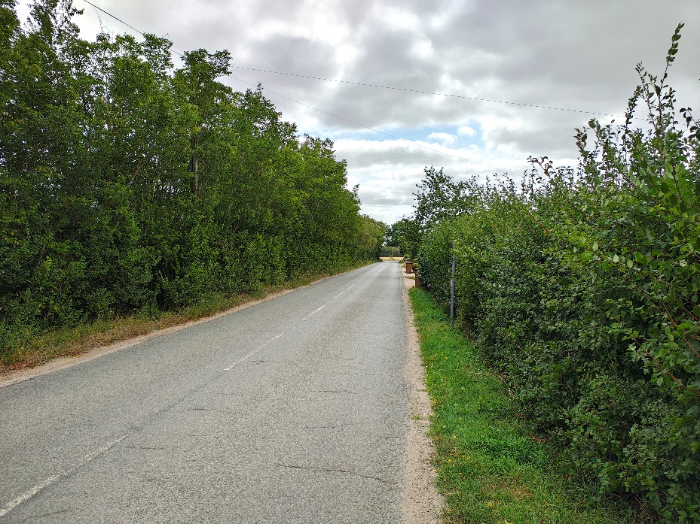  Incorrect  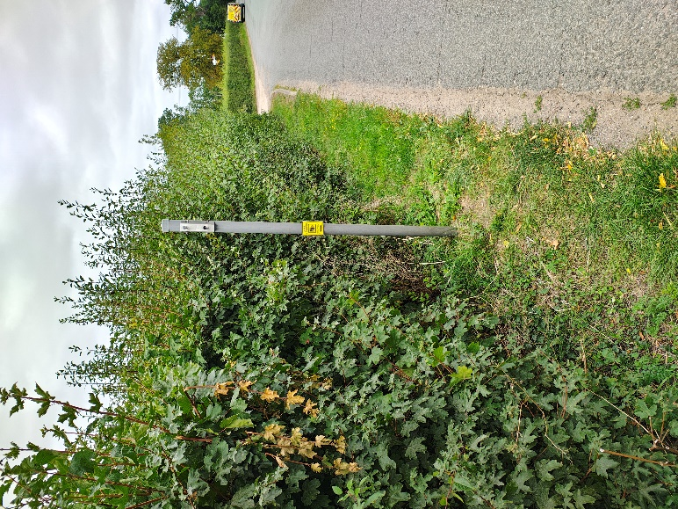
Purchase
How much does a SID cost? | Devices vary in price; those that SCC has reviewed cost between £2500 and £3500 approximately, depending upon functionality and battery quality.
Our PC/TC cannot afford to purchase a SID outright. What should we do? | In some instances, County Councillors have contributed to the purchase of a SID. It is quite feasible to purchase a SID in partnership with a neighbouring organisation. Community Speedwatch groups share SIDs, and this appears to work well.
Why is it not possible to purchase VAS rather than SIDs? | SCC follows Department for Transport advice and guidance for traffic signs which includes VAS. Only Highway Authorities or other approved bodies are deemed responsible for signs on the Highway. Such guidance does not apply to SIDs as they are not classified as signs. Hence SIDs can be deployed where communities want to be proactive as long as they comply with the site suitability assessment. By specifying that communities can only operate SIDs also removes any confusion for responsibility for who is operating what on the Highway.
What factors need to be considered if the SID is powered by a solar panel? | The size and weight of the panel combined with the SID may impact on the stability of a standard SID post. If a Council wants to purchase a SID with a solar panel, contact the supplier and ask for the following information:  - the recommended outside diameter of the post, and  - overall height of post required to accommodate a solar panel and the SID mounted at 2.1m  We will use this information to guide us with the post size and to calculate the foundations required to support the post, the SID and the solar panel.
If I purchase a SID powered by a solar panel, can we leave the device working at all times? | SIDs are meant to be in situ for no more than 4 weeks at a time. If you intend to purchase a SID that will remain permanently attached to a post, we will require you to set out how it will be deactivated for a period of at least a week between operations.
Why is it more expensive for the installation of a post with a solar panel? | Solar panels add to the weight and increase the wind loading on a post. We frequently have to install larger and thicker posts which require deeper foundations. This can also add to the time for the installation of the post and the traffic management for the works.
Will SIDs record speed data? | Some SIDs record data and a Parish or Town Council may decide to incorporate this in their specification when considering purchasing a SID.  SCC has access to data from its own recording equipment and does not require or accept data from Parish or Town Council owned SIDs.
Safety Training
What will volunteers be required to do and wear? | Volunteers will be required to work in accordance with the safe system of work which the Organisation has put in place. See SAFETY MANAGEMENT above.
How long should a sign be left at one location? | Organisations should leave signs in place for no more than 4 weeks and then remove or relocate them for a similar period. This should ensure that drivers do not habitually see SIDs and ignore them.

Finally, some Local Councils have asked why it takes so long to approve a site and install a post. The process of approval, assessing sites, ordering and installing posts can take a number of months.

Once SCC receives an application from a Local Council for a site to be assessed (with letters of consent from the nearest residents a signed Memorandum of Understanding and a guarantee of funding for posts), the process will begin.

It may be the case that SCC has to contact a Council to discuss the suitability of a site or to find an alternative location. This will generally be done by email/phone to avoid site visits. SCC will notify the Council of the final cost of the posts and an invoice will be raised.

SCC will then produce a job pack for each site which will be passed to the delivery teams. The job packs need to contain site plans, CDM checklists and underground utility plans to ensure the safe erection of the poles. It will need a period of time to produce these and then, once the works are ordered the contractor has up to 14 weeks to carry out the works – this time is needed to order materials, schedule the site works, sort out the traffic management and obtain any permits to operate on the highway.

30th April 2026

SITE SUITABILITY CHECKLIST: A separate form is to be complete for each site proposed. N.B. Applications will only be accepted with written evidence of residents’ approval.
Location
Parish / Town
Road Name / Number
Description of location
OS Grid Reference
https://gridreferencefinder.com
Photographs / Images
See Page 8 for photo requirements. Any photos that do not meet these requirements will need to be retaken, which will lead to delays.

General site details
Is the site within a 30mph speed limit? | Yes | No
Will the SID be visible to an approaching vehicle from 100m? | Yes | No
At 100m away, is the speed limit still 30mph? | Yes | No
For the entire distance that the SID can be seen is the road free of junctions and driveways? | Yes | No
Will the SID be placed on the same side of the road as approaching traffic? | Yes | No
Is there suitable off-road parking at or near the location to enable the SID to be mounted/dismounted safely and without obstructing the carriageway? | Yes | No
In the summer is tree or hedgerow growth likely to obscure the SID | Yes | No
Do local residents approve of the location? (Letter attached as evidence) | Yes | No
Is the location in a Conservation Area? | Yes | No

Specific site details
Is there an existing traffic sign pole at the site (this is preferred)? |  |  |  | Yes |  | No
Is the existing pole tall enough to mount the SID with the existing sign? |  |  |  | Yes |  | No
If the pole is by a footpath can the SID be mounted to allow at least 2.3m clearance between the ground and the bottom of the device? |  |  |  | Yes |  | No
Is the ground at the site firm and level? |  |  |  | Yes |  | No
Is there sufficient room at the site to allow safe access and 0.5m clearance from the edge of the SID to passing traffic? |  |  |  | Yes |  | No
Does the Council intend to use a solar panel with the SID? (see FAQ) |  |  |  | Yes |  | No
Outside diameter of post for SID and solar panel |  |  |  |  |  | mm
Overall height of post required for a solar panel & the SID mounted at 2.1m |  |  |  |  |  | m
SOLAR POST ONLY: Is the width of the pavement/verge at least 1.2m wide? |  |  |  | Yes |  | No
REGULAR POST ONLY: Is the width of the pavement/verge at least 1m wide? |  |  |  | Yes |  | No
Width of verge: |  |  |  |  |  | m
Form completed by:
Name: |  | Signature: |  |  | Date
Position:

Address and Email:

Authorisation for or on behalf of Suffolk County Council by:
Name: |  | Signature: |  | Date
Position:

Draft resident letter

Dear ______________________,

______________________Council wishes to seek permission from Suffolk County Council to erect a post at ___________________________________________ so that a speed indicator device (SID) or vehicle activated sign (VAS) can be temporarily installed.

Details of the SID/TVAS scheme can be found at www.suffolkroadsafe.com

Can you please indicate whether you:

a) Are happy for a post to be erected at XXXXX (location) so that a speed indicator device can be attached to it temporarily?

b) Would like more information and a meeting with a representative of the Parish Council to discuss further?

or

c) Are unhappy with the proposal and would not want a post at this location?

SCC will not consider a location if a resident is unhappy with the proposed siting of post.

Yours

Name
Job role

AGREEMENT
PURSUANT TO SECTION 72 ROAD TRAFFIC REGULATION ACT 1984

SUFFOLK COUNTY COUNCIL
AND
[ ]

Legal Services
Suffolk County Council
Constantine House
5 Constantine Road
Ipswich
IP1 2DH

AGREEMENT pursuant to Section 72 Road Traffic Regulation Act 1984 dated this.
[ ] day of [ ] BETWEEN SUFFOLK COUNTY COUNCIL of Endeavour House, 8 Russell Road, Ipswich, Suffolk, IP1 2BX (“The County Council”) and [ ] (“The Organisation”)

WHEREAS

- The County Council by virtue of the Highways Act 1980 and section 50 of the New Roads and Street Works Act 1991 is the highway authority for the County of Suffolk and the Traffic Authority for the purposes of traffic management in the County.

- The Organisation wishes to enter into an Agreement for the purposes of deploying on or near any road, other than a footpath or bridleway, mobile speed indicator devices (“the Devices”) for the purpose of alerting drivers to excessive speed on highways within the Organisation’s area.

- This Agreement is made pursuant to Section 72 of the Road Traffic Regulation Act 1984(the ‘Regulations’) and sets out the conditions upon which the County Council grants the Organisation permissions as permitted under the Regulations for the installation of Devices.

THE COUNTY COUNCIL AND [ ] AGREE:

- The Organisation shall only purchase Devices which are registered against the relevant Traffic Open Products and Specifications (TOPAS) (previously referred to as Department for Transport ‘Type Approval’)

- The Devices shall be installed and maintained at locations as shall be authorised in writing by an officer of the County Council or their Appointed Agent.

- The Organisation shall, if instructed by the County Council, immediately remove any Device from the highway which is not being operated at an authorised location; retrospective authorisation may be sought.

- The Organisation shall carry out any works specified by the County Council to ensure the installation of any Device in the highway does not prejudice the fabric of the highway, the County Council’s duty to maintain the highway or the health and safety of the public.

- The Organisation shall be responsible for the cost of repairing, maintaining or replacing the Devices and shall, if necessary, repair or replace any Device so as to avoid the Device becoming a nuisance or danger to users of the highway or to any other person including adjoining landowners.

- The Organisation shall ensure that any operations involved in the transportation, installation, use or maintenance of the Device comply with all health and safety procedures, laws and appropriate codes of practise including by way of non-exclusive, for example the provision of high-visibility clothing.

- The Organisation shall ensure the appropriate training, health and safety of any employee, volunteer or contractor engaged on its behalf to carry out any works or operations under this Agreement.

- The Device shall remain the sole responsibility of the Organisation and the County Council shall not accept responsibility for any damage to the Device or interference with such howsoever caused.

- The Organisation shall ensure that the Device will be in one location for no more than 4 weeks at a time or if it is operated by solar panel is it is disconnected for a week between operational periods.

- The Organisation will indemnify the County Council against any loss or damage arising out of any negligent act or omission of the organisation and /or its agents acting under its direction in relation to the installation, operation and/or removal of the devices. Such indemnity will be limited to the lesser of £10 million or the amount payable by the organisation’s insurers in respect of any claim.

- The Device must be placed to minimise the need for working at height, but with a minimum height clearance of 2.3m over a pavement (footway) or 2.5m adjacent to, or above, a cycleway.

- The Agreement shall be terminable without fault by either party upon three months written Notice being given by one party to the other at the addresses recorded in this Agreement.

- The County Council may terminate this Agreement without Notice if:
- The Organisation fails to comply with any of the conditions specified in the Agreement.

- The Organisation ceases to use or has abandoned the Device or intends to do so.

- The County Council as Highway Authority considers the withdrawal necessary for the purpose of the exercise of their powers and duties as Highway Authority.

- When the Agreement terminates the County Council may:
- Remove the Device(s) and reinstate the highway and recover from the Organisation the expenses incurred in so doing; or

- If satisfied that the Organisation can, within such reasonable time as the County Council may specify, authorise the Organisation at its expense to remove the Device and reinstate the highway.

15. All notices in connection with this Agreement shall be served upon the addressees of the recipient cited at the commencement of this Agreement or such other location as is notified by the receiving party for the purpose.

16. This Agreement is made and shall be construed under the Laws of England and Wales and the parties submit to the exclusive jurisdiction of the courts of England.

Agreed for and on behalf of Suffolk County Council by …………………………………….

Authorised signatory ……………………………………………

And for and on behalf of ………………………………by ………………………………….

Authorised signatory …………………………………….

Address …………………………………………………………………………………………………

…………………………………………………………………………….

